Tardis Printing Guide

Amazon filaments I have tried or look close to right color:
- eSUN 1.75mm Dark Blue PLA PRO (PLA+), Dark Blue (most my box pics are this eSUN filament)
- INLAND Micro Center PLA+, Dark Blue PLA Plus
- GIANTARM, MATTE PLA, MATTE NAVY BLUE
- TPOIMNS, PLA, NAVY BLUE

250mm build height is required for tallest piece, the Big Blue Box itself of course. At 249.5mm, it is within the limit of a 250mm max build height printer. If you have made modifications, such as installing volcano nozzle, glass plate or other thing that reduces the total build height in some way, you may need to undo them to proceed with this one part.
Cura Users: I recommend Cura 5.8.1 or newer for at least the Big Blue Box print. Z-Seam Options have been added / fixed so the seam can be assigned to a vertex (corner), so it will be practically invisible on the back of the box…DO NOT FORGET to place Z Seam on back side of box! 😊
IMPORTANT: Do NOT scale down project if your build height is less than the required 250mm for the big box! Because of the detailed fitment, the various printed-printed and printed-nonprinted parts will not fit together properly. It must be printed at 100% scale! If necessary, have a friend with a taller Z height printer print the 1 tall Big Box file for you (observing the calibration and print guidelines in this guide for that part, and buy them pizza and beer). You’ve been warned.
AS IMPORTANT: Before starting the project prints, be sure to calibrate flow for the specific filaments you will be using! Otherwise the tight clearances for mating parts will likely not work (0.2mm in most places). 100% slicer flow generally results in wider wall extrusion width than slicer is set for. This works fine when printing a single display piece, but when mating, fitment sends you down a troublesome rabbit hole to correct. If ignoring the following guidance, setting flow rate in slicer for all but first layer for all blue filament pieces at 95% should work fine…
Begin by downloading a .4mm nozzle quick print flow calibration cube from Printables courtesy of Hume Beam (https://www.printables.com/model/81314-flow-calibration-cube). In the description he describes the process and simple math.
Using calipers, I find PLA generally extrudes 2 walls (or shells) with .4mm nozzle to .88mm width with 100% flow, but 92-96ish% flow is more accurate to .80mm when clearances are important. The flow can also vary between manufacturers and even colors from same manufacturer, which is why you want to do this for each roll (and even nozzle size if not doing all with 0.4mm) for this project.
If you already know how to calculate flow from a calibration model, you can skip the reading and download .4mm nozzle .8mm wall model here. If desiring a MUCH faster print for the big box print and are prepared to accept more rounded edges/features for big box file than with .4mm nozzle, the .6mm nozzle flow test file is here. I discourage 0.6mm nozzle for this project as all inside/outside corners will be more round, and sanding of mating parts (adapters, top sign frames, etc) will be necessary. Bottom line, the .4mm nozzle is worth the extra print time, both visually and to reduce post processing.
Clearances are generally 0.2mm for friction fits and 0.3mm adapter depths and lid on box. You may need to use hobby knife to cut out filament blobs and stringing. Filing a bunch if you fail to heed the warning about flow calibration!
Overhangs are minimized by design and correct orientation on bed (parts should open in correct orientation in slicer).
I’ve included a ‘Box Test Section’ you may print before the big show if you desire to confirm smaller parts (top sign inner and outer frames, windows, window frames, adapters) fit as expected. It was immensely useful during my CAD design stage to tweak aspects before finalizing and investing a lot of filament and time with confidence. Use your least favorite PLA color to conserve the TARDIS Blue (eSun Dark Blue PLA+/Pro) and do flow calibration first.
You can also decide what speed to print the big box outer walls if you change print speed on the fly every handful of layers and examine the ringing as it prints. I can go 80mm/s before under-extruding (nozzle temp adjusted higher to compensate of course), but found during test section print that 30mm/s was the speed limit to avoid significant ringing that I know would drive me crazy once it was a display piece. So for my own big box slice, 30 for outer walls and 50 for about everything else but first layer works great.
Last quick tip: -0.2 Initial Layer Horizontal Expansion was DEFINITELY helpful for fitment. Window panels, window frames, inner/ outer sign frames, door sign frames, brainbox and adapter blanks especially. But I used that
setting for ALL prints to defeat elephants foot and fitment issues.

ALSO AS IMPORTANT:
- Align Seams!!! Generally at the back or back corner if model is oriented forward. NO RANDOM SEAM, except for adapters. Adapter fitments seems to work better with random.
- If not using printer enclosure, consider closing windows and air vent to the room so A/C (or heat) coming on or winds outside don’t result in separation from print bed and warping (thermal variation).
- DO NOT USE SUPER GLUE! It WILL leave whitish color after drying. Stick to hot glue gun and cheap model plastic glue

LAST General Thought:
Below, I have noted what I felt are the most important settings to ensure best chances of great first prints, based on my many experiences printing all parts many (and many more) times during development.

Post Processing
Because clearances are generally .2mm for friction fit with calibrated flow (or at least sliced for 95%), you will find some interfacing pieces may need light sanding at z seams/blobs, outside corners. Or use a knife to cut off corner nubs and such. Good news is almost none of that is visible after final assembly. But resist removing the nubs on the adapter hole faces in big box and lid files. They help retain adapters in the holes a bit. There are also nubs on ends of top sign frames. These nubs increase insertion force, but hold the parts together well. Still, dabingb concealed spots with plastic glue for the adapters so they don’t pull out later works if not already a firm hold.

Box Test Section
Allows you to test recommended slicer settings and fitments for the Big Blue Box and parts, before investing the most plastic for the big box itself. Preferably, use your LEAST favorite, non-silk PLA to conserve blue material for project. Test opportunities include:
- Acceptable Ringing speed for outer wall to make different from other print speeds
- Support issues with window top support
- Bridging of the inside diagonal adapter wall overhang (when recommended support blocker from just above window opening to top of model is used)
- Top sign back light COB strip channel
- Top layers surface quality (try Iron setting if desired)
- Fitment of adapter wedges
- Fitment of inner and outer top sign frames
- Fitment of window panel and frames in window opening
- Satisfactory Infill % to support top layers (I use 20% near them)
- Police Public Call Box sign/label fitment in the frames, and mounted look
My slicer settings report less than 60g of filament and 5.4 hours to print. Use same settings suggested for Big Blue Box, or the settings you find from test section print works for YOU.
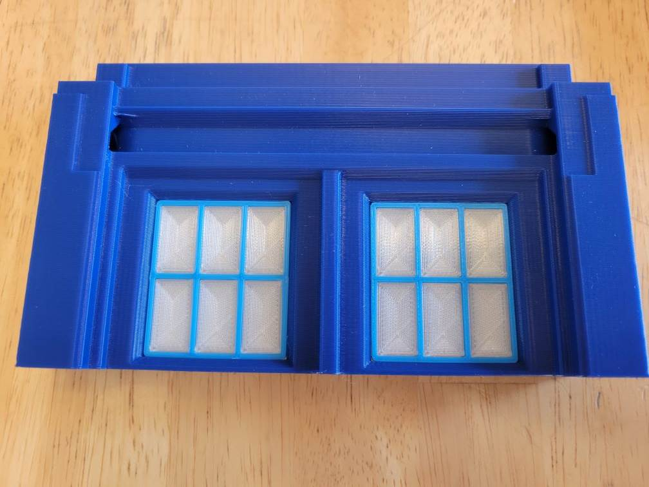
Support: Normal support, 70 degree overhang. Most non-90 degree overhangs are 45-60 degree and should print well, and the steeper stuff is inside the box for function, so no worries of it not looking great. Support pattern Concentric, with Interface at 100% should be great. Window tops are the ONLY supported overhangs when sliced with recommended support blockers in place.
I STRONGLY recommend a support blocker (X and Y axis covering the WHOLE model) from just above the window ledges to the top of model, so when sliced the preview only shows supports for the windows (and filling those openings). Otherwise you get 2 sets of narrow tall supports from bed to past windows that will likely fail and should not be necessary (turn on Enable Bridge Settings). Alternatively you could place support blocks at those 2 diagonal overhangs. But slicer MAY try to place support in the top sign backlight channel, and it will be challenging to remove well.
Again, WINDOWS ARE THE ONLY PLACE YOU SHOULD SEE SUPPORTS. You may need to increase ‘Minimum Support Area’ value to a few mm to eliminate some support weirdness.
Enable Bridge Settings in Cura’s ‘Experimental’ section should get you past the toughest hurdle: 2 adapter hole walls hanging above window level. Most printers can bridge WELL when settings are tweaked, or at least enabled. Enabling this setting DOES help bridge those 2 gaps, as well as improve the window overhangs (but do still use supports for those), and window supports just pop out easy peasy.
First layers of those 2 big overhangs were slightly droopy as a result of no support, but didn’t have thinner fragile layers and adhesion issues. Tweaking those settings is a judgment call on your part. Box Test Section print should give you confidence.
Use the noted minimal or no ringing speed from Box Test Section print (if you varied the speed to test for it) for the OUTER wall speed (mine is 30mm/s). Inner walls can be faster (mine is 50mm/s) with appropriately higher temp (to avoid under extrusion). This trick will cut a handful of HOURS off the print, while maintaining awesome exterior and interior.
Top/Bottom pattern of LINES (as opposed to concentric) avoids goofy little gaps on top of base and top shelves of model above corner posts and adhesion issues when layers are aligned.
Z seam at BACK with hide or expose option looks well when printed.
Use Combing mode Not on Outer Skin or something. No sense having hot nozzle travel mar a magnificent print, as well as leave stringing throughout the inside.
Wall/Shell overlap 15-20%. This ensures the outside lines (printed after inner) bond and hold well for the steeper overhang areas.
Wall ordering: Inside before outside!!! Or you’ll regret it (learn from my experience). The lines need something to attach to laterally when doing overhangs.
Personally I use 4% Infill, Grid pattern, for most of the volume. Good horizontal strength while still providing a line to hold filament at the corners. With Cura and using an additional support blocker, I used ‘per model settings’ (mesh overlap) for blocker model to increase infill to 20%, GRID pattern starting about 10 layers under the top surfaces. This technique saved a LOT of time and filament, while still achieving great top surface look. Consider same technique for top of the base.
I preferred 4 model top layers with 2 Skin Edge Support Layers (Infill section in Cura) to avoid any chance of an upper surface not printing well.
Faster speeds (50mm/s for me) except outer walls, which I reduced to the maximum speed for minimal ringing based on the box section test file (30mm/s).

Big Blue Box
Remarkably, this is a safe print piece. No brim nor raft necessary, though I always like a skirt to verify the first layer will behave. Use same settings as worked out for the Box Test Print, just moving the support blockers up.
Support: Normal support, 70 degree overhang. Most non-90 degree overhangs are 45-60 degree and should print well, and the steeper stuff is inside the box for function, so no worries of it not looking great. Support pattern Concentric, with Interface at 100% should be great. Window tops are the ONLY supported overhangs when sliced with recommended support blockers in place.
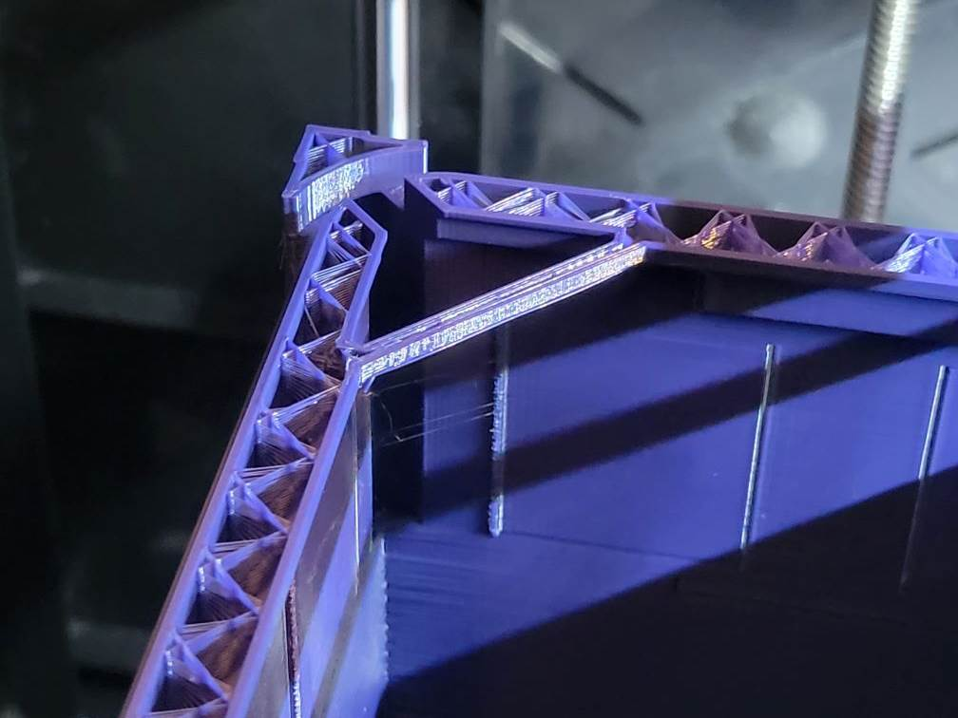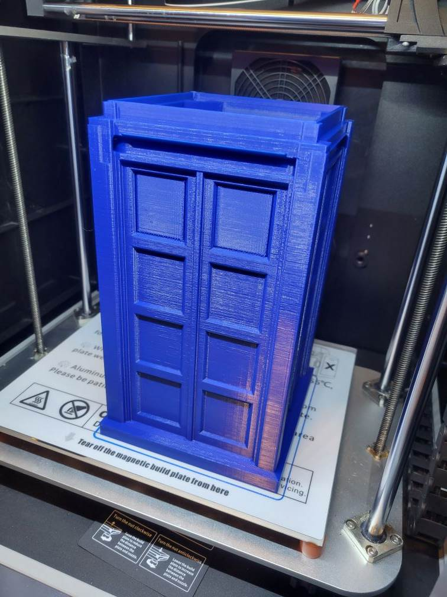
I STRONGLY recommend a support blocker (X and Y axis covering the WHOLE model) just above the window ledges to the top of model, so when sliced the preview only shows supports for the windows (and filling those openings). Otherwise you get 2 sets of narrow tall supports from bed to past windows that will likely fail and should not be necessary (turn on Enable Bridge Settings). Alternatively you could place support blocks at those 2 diagonal overhangs. But slicer MAY try to place support in the top sign backlight channel, and it will be challenging to remove well.
Again, WINDOWS ARE THE ONLY PLACE YOU SHOULD SEE SUPPORTS. You may need to increase ‘Minimum Support Area’ value to a few mm to eliminate some support weirdness.
Enable Bridge Settings in Cura’s ‘Experimental’ section should get you past the toughest hurdle: 2 adapter hole walls hanging above window level. Most printers can bridge WELL when settings are tweaked, or at least enabled. Enabling this setting DOES help bridge those 2 gaps, as well as improve the window overhangs (but do still use supports for those), and window supports just pop out easy peasy.
Top/Bottom pattern of LINES (as opposed to concentric) avoids goofy little gaps on top of base and top shelves of model above corner posts.
Z seam at BACK with hide or expose option looks well when printed.
Use Combing mode Not on Outer Skin or something. No sense having hot nozzle travel mar a magnificent print, as well as leave stringing throughout the inside.
Wall/Shell overlap 15-20%. This ensures the outside lines (printed after inner) bond and hold well for the steeper overhang areas.
Wall ordering: Inside before outside!!! Or you’ll regret it (learn from my experience). The lines need something to attach to laterally when doing overhangs.
Personally I use 4% Infill, GRID pattern, for most of the volume. Good horizontal strength while still providing a line to hold filament at the corners. With Cura and using an additional support blocker, I used ‘per model settings’ (mesh overlap) for blocker model to increase infill to 20%, GRID pattern starting about 10 layers under the top surfaces. This technique saved a LOT of time and filament, while still achieving great top surface look. Consider same technique for the base.
I preferred 4 model top layers with 2 Skin Edge Support Layers (Infill section in Cura) to avoid any chance of an upper surface not printing well.
Faster speeds (50mm/s for me) except outer walls, which I reduced to the maximum speed for minimal ringing based on the box section test file (30mm/s).
My settings result in a 1 day 17 hour box print, using 460g of filament, or about half a role, and 0.2 layer height. You’ll use up most the rest with other parts (and perhaps a few do overs).
I print a box using 0.3LH and 0.6 nozzle. Results were okay. It shaved print time down to 1 day 5 hours. BUT the overhangs suffered a bit and all inside / outside corners and other parts fitment suffered. So I’ve reverted to 0.2LH and .4 nozzle.
Post Processing: If window supports don’t press out easily (you didn’t Enable Bridge Settings in Experimental section), I used a straight pick to punch a few holes through the middlesupport area, and hobby knife to slice to the edges. Breaking across the middle, they should bend out at top and bottom. Smooth top and bottom faces to the corners with knife or file to ease window frame fit.

Light Jig
This is where you mount 4 8mm COB strip lights to illuminate the windows. If not wiring in power/lights, you should still print this as it retains the window panels in place, conceals/protects them when goodies and hands go in/out, and is integral to the clean looking internal design of the model.
No supports needed.
3 walls with .4 nozzle, and whatever layer height you’re use to is fine. 4% Lines infill in Cura. No post processing should be needed.

Light Jig Retaining Ring
Simple print, locks in light jig, is self retaining, and blends bottom of jig to inside of box walls.
Print flat side down, 3 walls, no infill or supports.

Brain Box / Box Bottom
This part is dual purpose. It provides the false floor which conceals the electronics and wiring underneath, as well as allowing you to arrange and mount hardware inside it before inserting in the big box after final testing of all functions and good connections. If using BASIC TARDIS version, 2 files are included for shallow with hidden storage or deep bottom options.
POWER version: Enable Bridge Settings, and NO supports.
Post processing: If too snug a fit sliding into bottom of TARDIS, sanding/filing outer Z seams will fix it.
It is lightly self-retaining when fully slid into TARDIS. At end of assembly, applying the self retaining cover ensures the Brainbox is locked in place.

Top Sign Frames
4 walls, 0.2 layer height, no supports, 10% infill. Inner and outer frames snap together, sandwiching the top sign in place. Then the combination snaps onto the box with a ledge for alignment. Pretty snug fit due to the nubs on ends, but they shouldn’t be loose, or even need glue. Light sanding at back corners may be useful depending on your print.

Door Sign Frame and Backing
4 walls, 0.1 layer height, 15mm/s speed. No brim or support. The door sign can be stuck to the backing panel, then trapped with the frame. Should fit very well together on door panel.

Adapters
2 walls, 0.2 layer height, 5% infill, reasonably slow (25mm/s). Random Z-seam.
When suitably oriented, only the pogo pin connector adapters need supports. Support XY distance 1mm is great. The receptacle for the pogo piece must be on top for proper fitment. The Kit versions have bottom and side openings for wire exit flexibility.
Magnet Adapter prints with hole facing up. Sized for concealed 6x3mm magnets.
Adapter Blanks are designed so end users can choose their own solutions for power plug port into the box base (my kit includes a USB C female port), and the wireless connection between top of box and lid. Same shape, size and depths for all of them. If ordering a kit, 4 pin pogo connectors, 4 magnets for the opposite corners, and USB C port adapter files will be included and you can use those files.
If not using the kit, you’ll need to download the Adapter Blank CAD file and model your connector manually. Or print the blank and experiment with drilling, using soldering iron on plastic or some such thing. Possibly try to use the kit versions and make them work for what you get on your own. I’m open to collaboration to model more popular options.

Window Frames
.4mm nozzle! The inside corners using .6 nozzle won’t allow the window panes to fit through.
SLOW SPEED: First layer 10-15mm/s, then 25 max.
Post processing: perhaps just a few sands or slices around outside for any inaccuracies (Z seam bulge), as all sides slip through something when mounted. But don’t sand more than necessary, as you want friction fit/hold to the box window openings.

Window Panels
.4mm nozzle
Clear filament works well. White reduces illumination from lights quite a bit. Try both if you have them and decide. Included is half window (2 per box side) and full panel (1 per box side). I could not find a satisfactory process that did not require sanding and painting and still conceal print lines. If you’re okay with illuminating print lines (and reallllly not okay sanding and painting), try using white filament.
- 0 top and bottom layers
- 2 walls
- 105% infill
- Infill Lines all aligned [90, 90] for example
- Higher than normal temp
- High infill flow rate (100-105%)
- You will likely need to slice nubs off the pane sides with knife some so frames fit
- I enabled Ironing and Only Top layer using ZigZig pattern settings and monotonic order.
- Slower than usual print speeds
- This great YouTube video by Stephan of CNC Kitchen is very insightful for clearer prints. Linked HERE.
- Sanding the top of panes to remove ironing inaccuracies and airbrushing or rattle can with white paint was the best visual look I found after MANY model, slicing and processing variations.

The goal of these unique print settings is to eliminate gaps in the plastic lines inside the clear print. Thus maximizing illumination. I was happiest with outcome when lines of print in paper under the panel were fairly clear and distinct.

Post Processing: Use a printed window fame and try lightly pressing into window panel. Cut away print nubs or seams where there is resistance, then retry until frame fits well.
Prepping clear filament windows: My process was rough sanding panes with 150 grit paper wrapped around a nail file board. Then sanding with 220 grit paper. Wash away sanding dust, fully dry. Then airbrushing pane tops and outer row sides with whit (or try thin layer of rattle can acrylic white). Use airbrush air to fully dry quickly, then check against prepped and powered window light jig. If spots of paint are not dry, it will not look right. If dry and not right, you can apply more paint, or wash off and try again. It took a little practice to not use airflow too high or brush too close, thus avoiding ripples. But after a couple times, they all started looking great. I like to give a second coat after finishing the first round. The backlighting looks satisfactorily uniform with this method, and no filament lines. Just great illuminated diffused white.

Bottom Cover
Easy, fairly short print. Nothing to clean up afterwards. The cover hides the hardware and wiring.
Flat side down, 3 walls, no infill or supports.

Lid
3 walls, and use shorter layer heights and more top layers to reduce island layer effect for the sloped top (mine are 0.16LH and 5 top and bottoms). 70 degree overhang angle. 100% support interface. Enable Bridge Settings.
Same speed settings as big box print. Slower outer walls to reduce ringing. Everything else faster is okay.
Post Processing: Angled Needle pick to pry out 2 inside corner supports.

Globes
Included in my kits if ordered. Otherwise,
Clear PLA, 8 walls, .1 or .12 layer height and 0.4 nozzle. LOW speed! Open side down with brim. As it’s so small, it needs it. NO supports. 2 variations are included in the kit and digital downloads (Smith and Tennant).

Cap
4 walls, .4 nozzle, shortest layer height. LOW speed! Extra top and bottom layers. The inside overhang slices weird, and I’ve found using support with interface works best. Use larger Support X/Y Distance (1mm) to make easier to remove.
It may take a couple tries with tweaked settings. Good news is it uses almost no filament and is done in a few minutes.

Door Hardware
Included in my kits if ordered, these are included to save you buying an otherwise blah colored filament. Otherwise, silver / gray filament, 4 walls, shortest layer height, no supports. SUPER SLOW! Not a most authentic design, but designed to print well at such small scale.
Recommend NO brim, and use smooth build plate and glue if you have it (tiny print surface area adhesion needs it). Brim won’t clean up well when trimming away and you’ll probably cut yourself.
Textured buildplate works as well, but chances of losing bed adhesion are higher. Just go slower.

